NAAN MUDHAVAN ASSIGNMENT DOCUMENT

**COURSE TITLE** : DIGITAL MARKETING

**COLLEGE CODE** 1105

**COLLEGE NAME** : GOJAN SCHOOL OF BUSINESS AND TECHNOLOGY

**NM ID NAME**

**REGISTER NUMBER**

: 3EA7F27A8CDE539BED94358A43EF721C

: SANTHOSH B.S

: 1105201063157

**YEAR** : 4TH YEAR

**DEPARTMENT** : ELECTRONICS AND COMMUNICATION ENGINEERING

1. Create a blog or website using Blogspot and Wordpress. Customize the theme design and post new article with 500 words.

Link: [https://boxingfitnessstudio.blogspot.com/2023/10/boxing-and-fitness-sudio.html](https://boxingfitnessstudio.blogspot.com/2023/10/boxing-and-fitness-sudio.html?m=1l)



1. Create a New Facebook Or Social Media Business Page and post one social media poster for your Brand

Link:

[https://www.instagram.com/boxing_and_fitness_studio2023?igshid=NGVhN2U2NjQ0Yg%3D%3D](https://instagram.com/boxing_and_fitness_studio2023?igshid=NGVhN2U2NjQ0Yg%3D%3D)

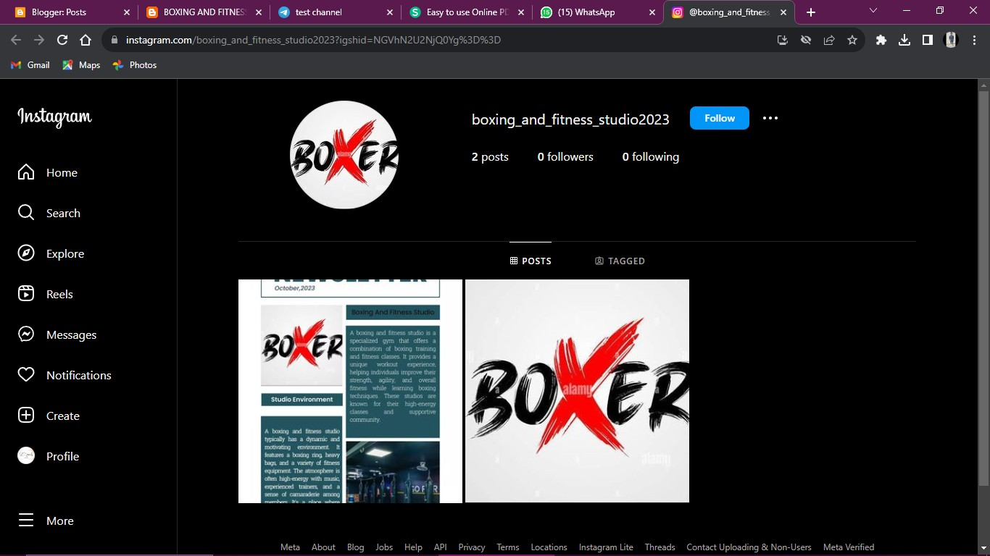

1. Create and design a social media advertisement poster using canva.



welcomes you

@boxingfitness_sandy's way

1. Create email newsletter design using MailChimp or canva tool.

Link: [https://boxingfitnessstudio.blogspot.com/2023/10/news-letter.html](https://boxingfitnessstudio.blogspot.com/2023/10/news-letter.html?m=1)

